**Darren Pardp**

**Rutgers Data Science Bootcamp**

**Visual Basic Homework**

**May 4, 2019**

**Unit 2 | Assignment - The VBA of Wall Street**

**Multi Year Stock Data Results**

**2014**

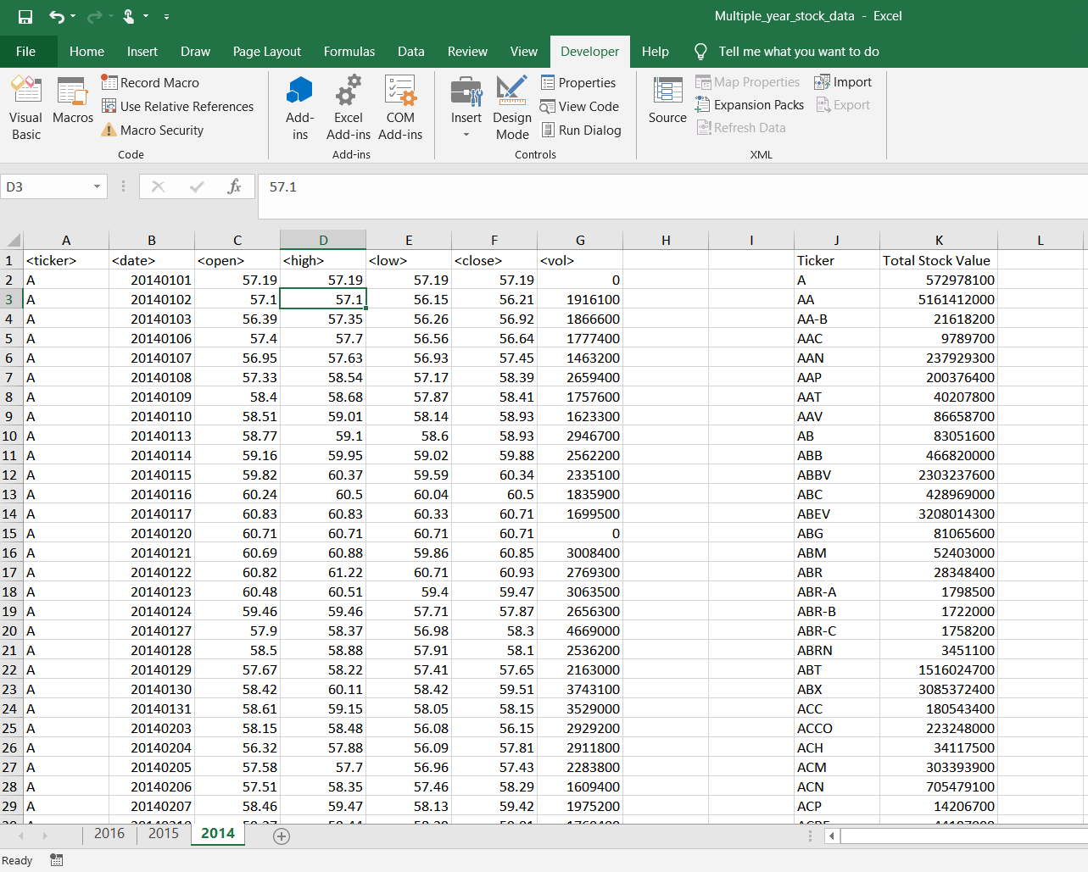

**2015**

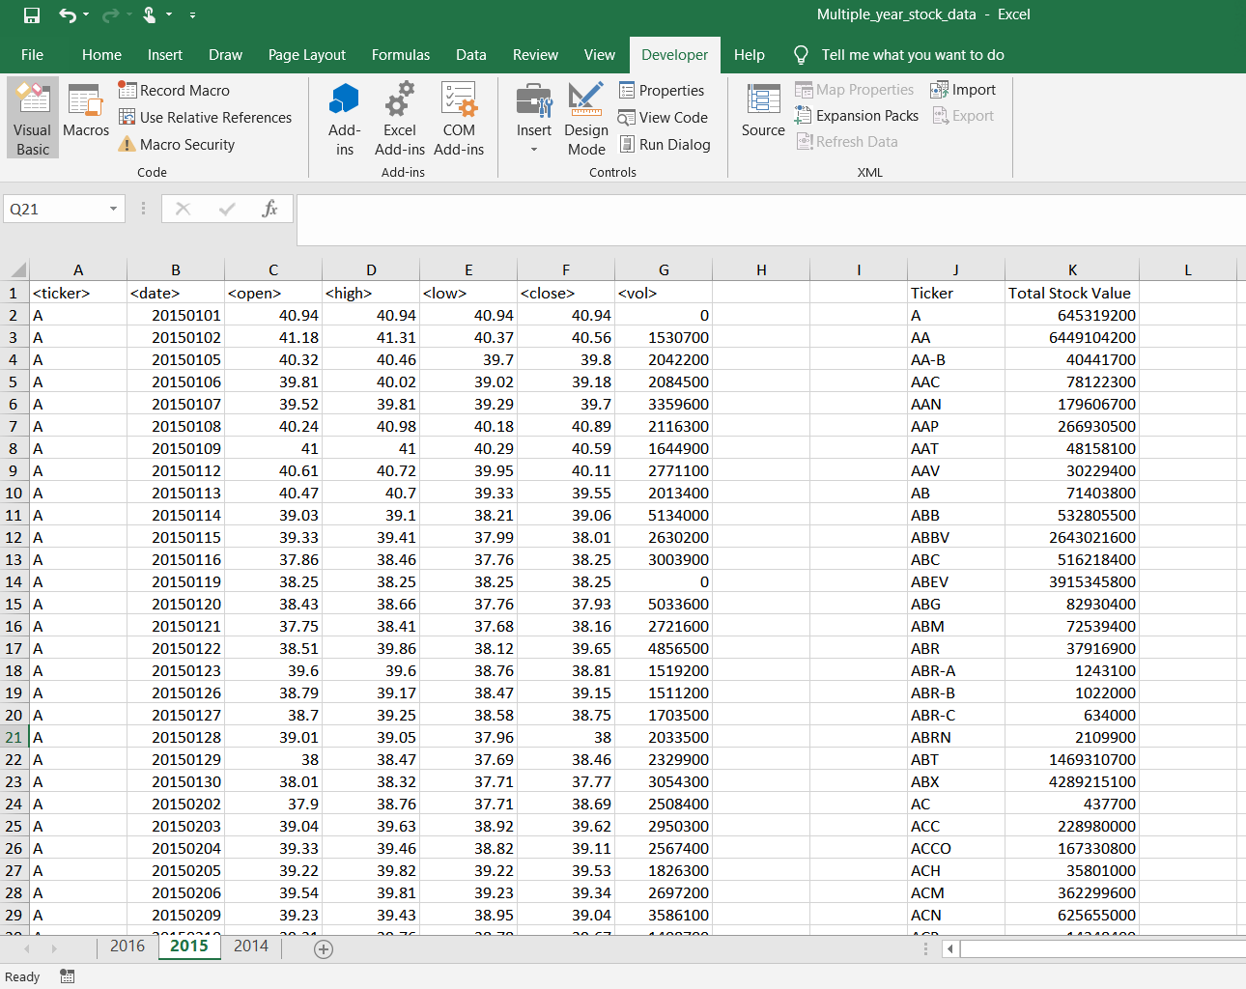

**2016**

